Assignment 4: Assignments on In-built Data
Structures

Name: Rajesh Mahendra Anerao
Sub: Python for Engineers (PFE)
Roll No.: 15
Branch: CSE-Data Science Engineering

Q 1.
Problem Statement: Program to Create and view elements of a list
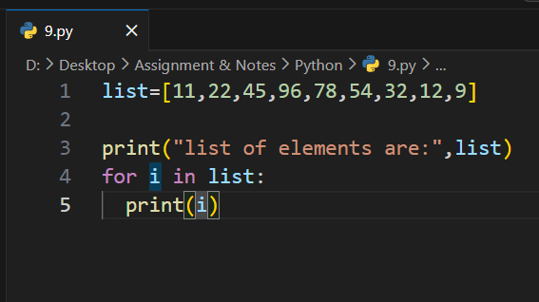
Output:
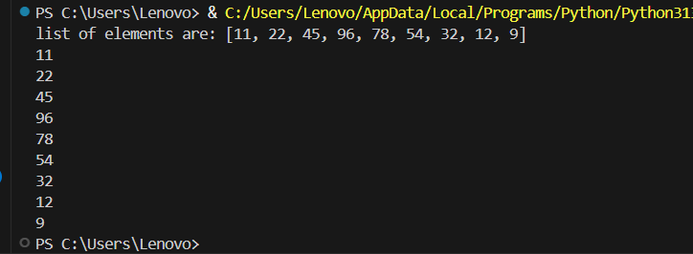
Conclusions:
Duplicate items can be removed from a list using set().

Q 2.
Problem Statement: Program to Create and view elements of a tuple
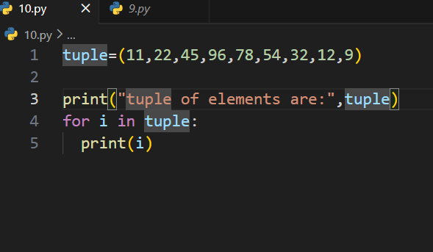
Output:
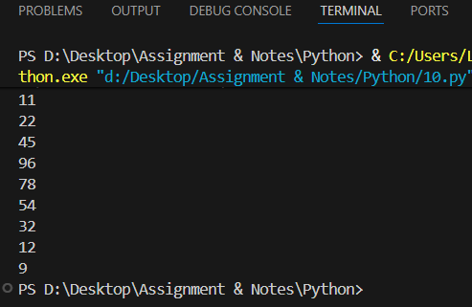
Conclusions:
Duplicate items can be removed from a list using set().

Q 3.
Problem Statement: Program to access List Index and Values
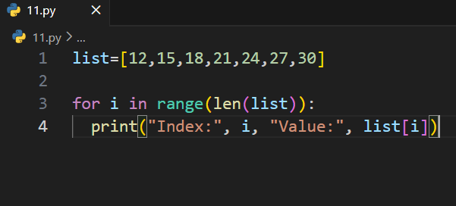
Output:
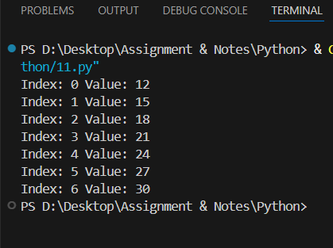
Conclusion:
A set stores only unique elements.

Q 4.
Problem Statement: Program to add two Lists
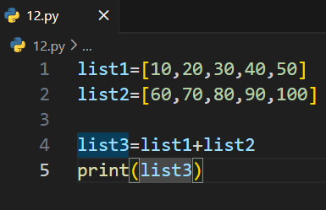
Output:
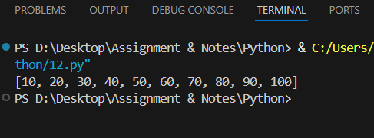
Conclusion:
Dictionary values can be viewed using .values().

Q 5.
Problem Statement: Program to check if a List is Empty or Not
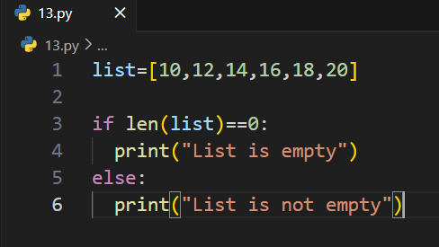
Output:
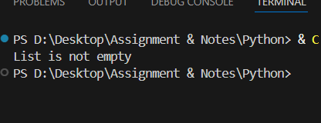
Conclusion:
Dictionary keys can be viewed using .keys().

Q 6.
Problem Statement: Program to Find the Largest Number in a List
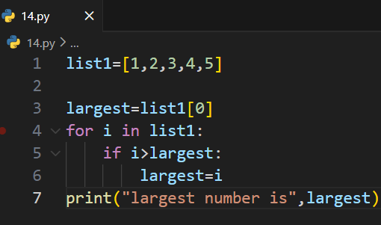
Output:
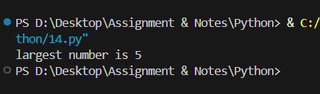
Conclusion:
New items can be inserted and existing items can be deleted from a dictionary.

Q 7.
Problem Statement: Program to Find the Second Largest Number in a List
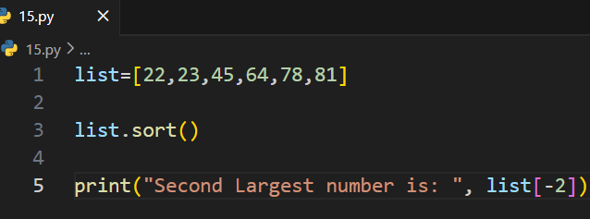
Output:
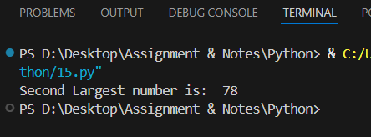
Conclusion:
A dictionary can be sorted by values in ascending or descending order.
Q 8.
Problem Statement: Program to Put Even and Odd elements in a List into Two Different Lists
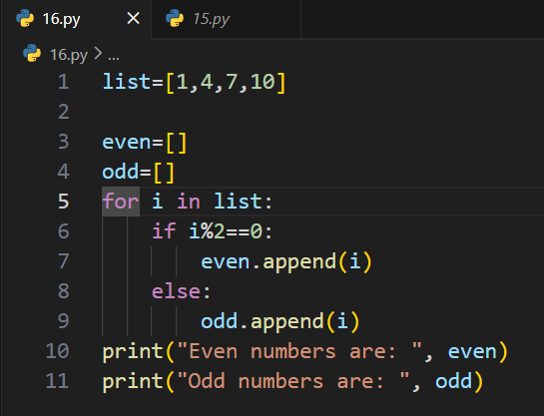
Output:
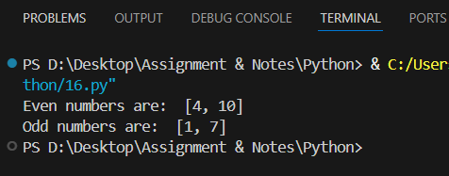
Conclusion:
Two dictionaries can be combined to create a new dictionary.

Q 9.
Problem Statement: Program to Find all Numbers in a Range which are Perfect Squares and Sum of all Digits in the Number is Less than 10
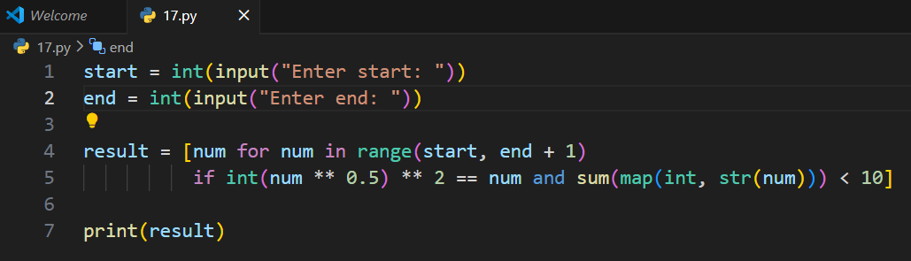
Output:
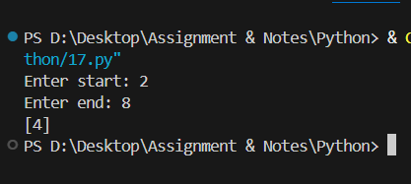
Conclusion:
The in operator checks whether a key exists in a dictionary.

Q 10.
Problem Statement: Program to Generate Random Numbers from 1 to 20 and Append Them to the List
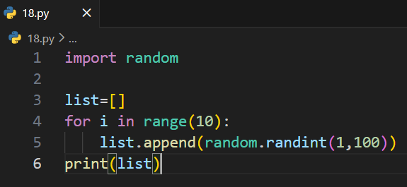
Output:
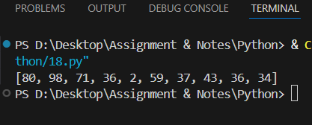
Conclusion:
Two dictionaries can be merged into one.

Q 11.
Problem Statement: Program to Remove the Duplicate Items from a List
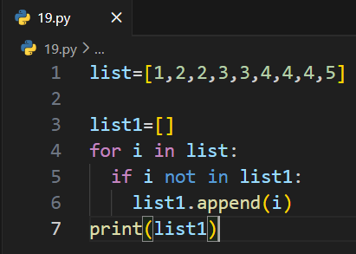
Output:
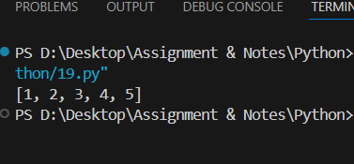
Conclusion:
Maximum and minimum values in a dictionary can be found using max() and min().

Q 12.
Problem Statement: Program to create and view a dictionary
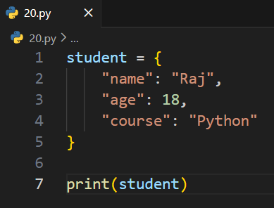
Output:
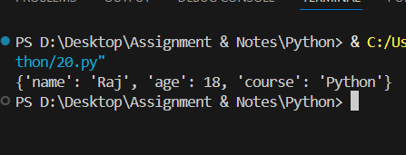
Conclusion:
Multiple elements from a list can be added to a set using .update().

Q 13.
Problem Statement: Program to create and view elements of a set
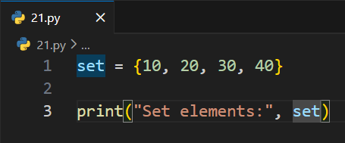
Output:
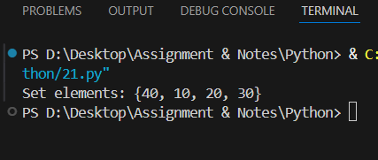
Conclusion:
symmetric_difference_update() keeps only elements not common in both sets.

Q 14.
Problem Statement: Program to Print values of dictionary
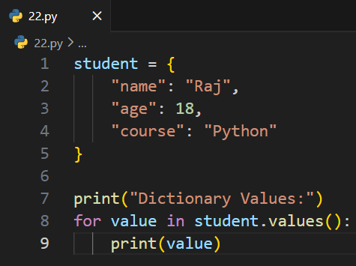
Output:
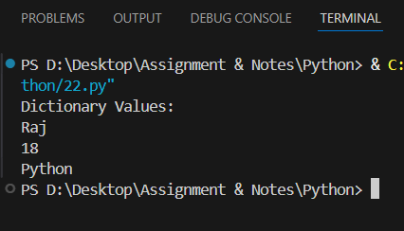
Conclusion:
symmetric_difference() returns elements present in either set but not in both.

Q 15.
Problem Statements: Program to print all keys of dictionary
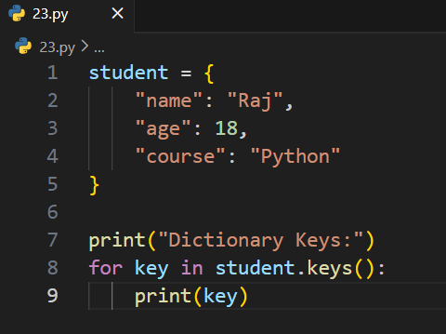
Output:
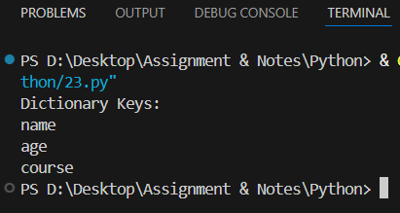
Conclusion:
isdisjoint() checks whether two sets have common elements.

Q 16.
Problem Statements: Program to insert and delete from dictionary
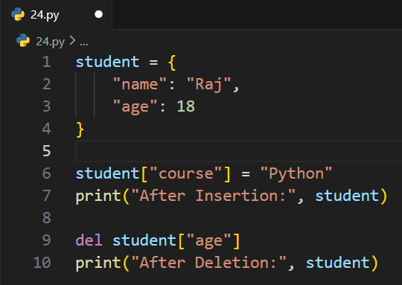
Output:
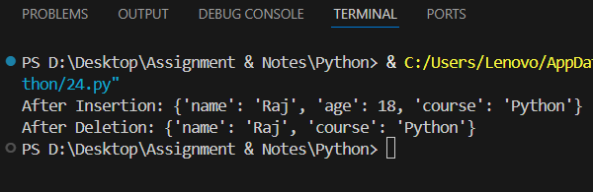
Conclusion:
intersection_update() keeps only the common elements in both sets.

Q 17.
Problem Statement: Program to sort (ascending and descending) a dictionary by value
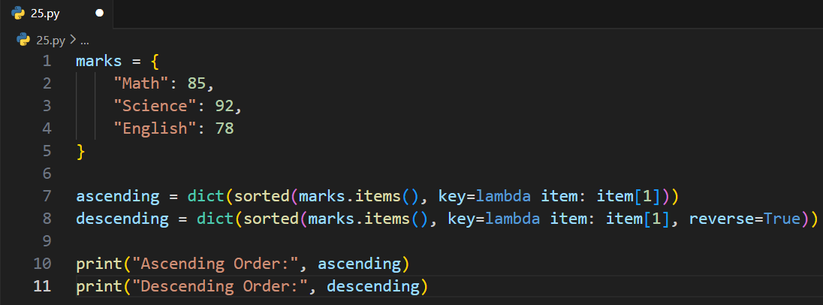
Output:
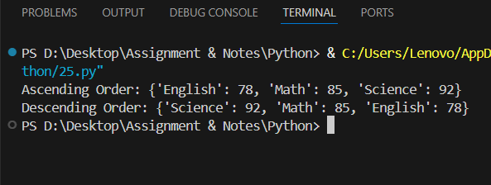
Conclusion:
A list can be created and displayed using square brackets [].

Q 18.
Problem Statement: Program to concatenate dictionaries to create a new one
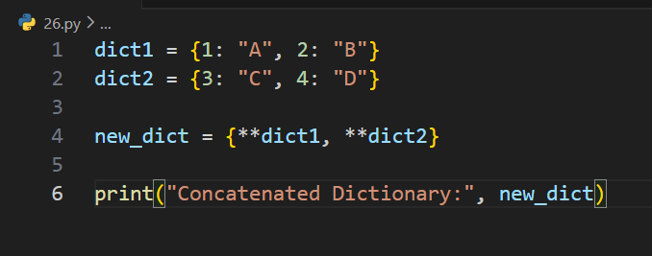
Output:
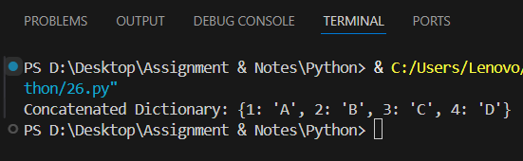
Conclusion:
A tuple can be created and displayed using parentheses ().

Q 19.
Problem Statement: Program to check whether a given key already exists in a dictionary.
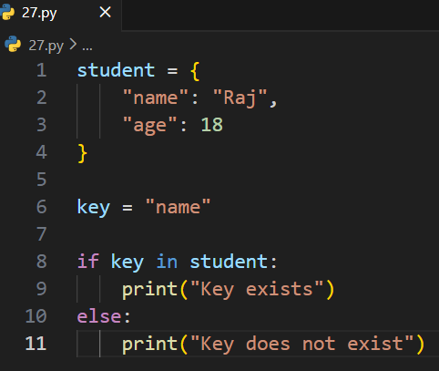
Output:
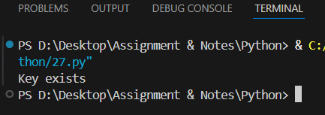
Conclusion:
List items can be accessed using their index numbers

Q 20.
Problem Statement: Program to merge two Python dictionaries
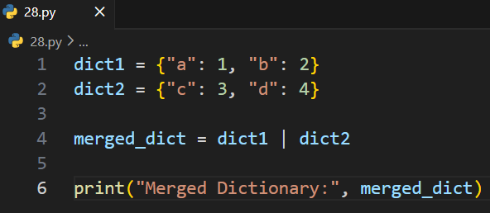
Output:
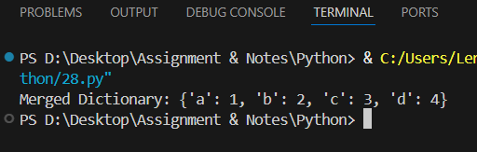
Conclusion:
Two lists can be added using the + operator

Q 21.
Problem Statement: Program to get the maximum and minimum value in a dictionary
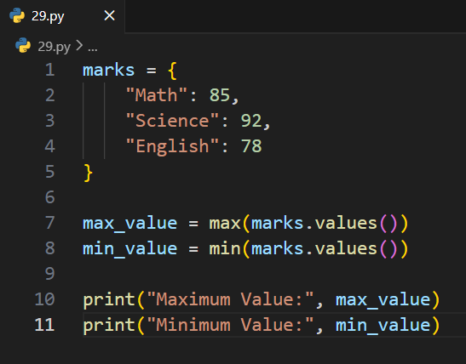
Output:
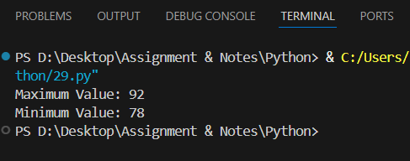
Conclusion:
A list is empty if its length is 0.

Q 22.
Problem Statement: Program to Add a list of elements to a set
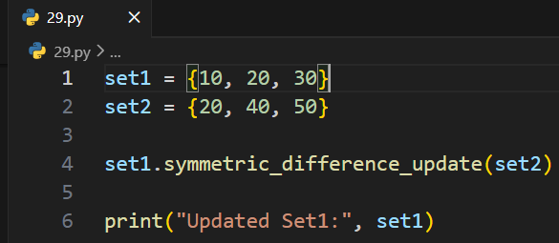
Output:
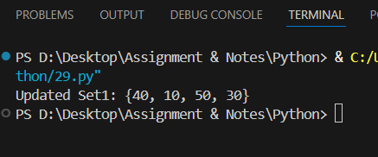
Conclusion:
The largest number in a list can be found using max()

Q 23.
Problem Statement: Program to Update the first set with items that don’t exist in the second set
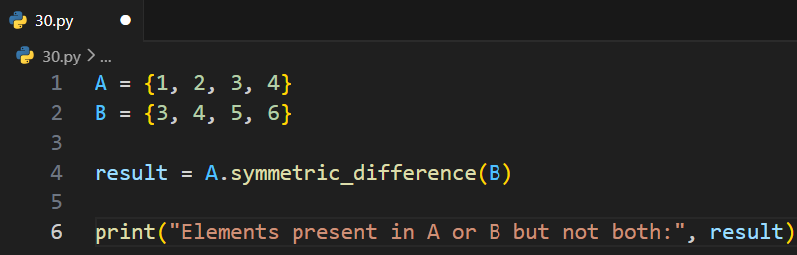
Output:
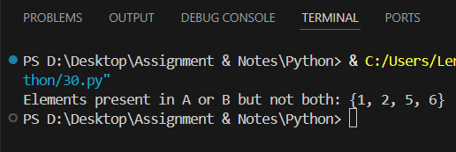
Conclusion:
The second largest number can be found by sorting the list

Q 24.
Problem Statement: Program to Check if two sets have any elements in common.
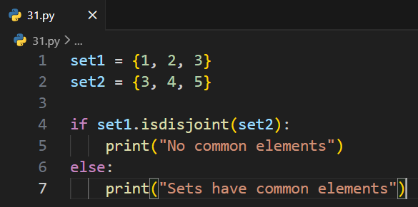
Output:
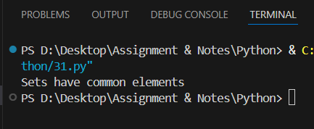
Conclusion:
Even and odd numbers can be separated into different lists

Q 25.
Problem Statement: Program to Remove items from set1 that are not common to both set1 and set2
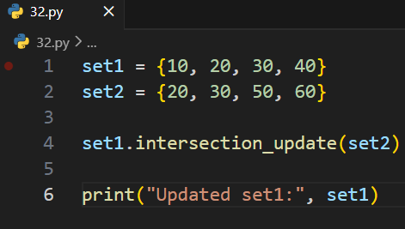
Output:
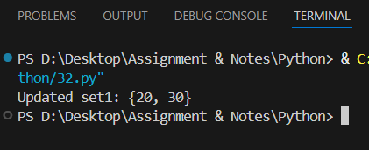
Conclusion:
Perfect squares with digit sum less than 10 can be found using loops and conditions.

Q 26.
Problem Statement: Program to Return a set of elements present in Set A or B, but not both
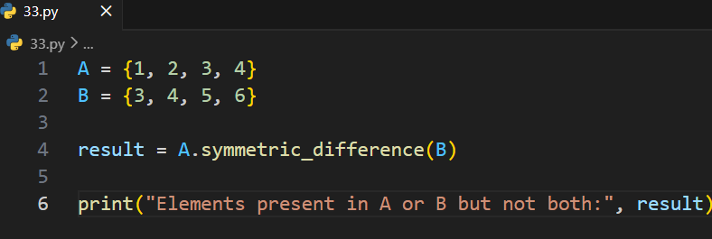
Output:
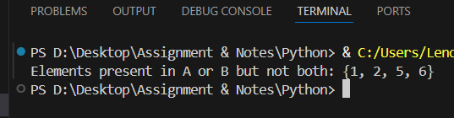
Conclusion:
Perfect squares with digit sum less than 10 can be found using loops and conditions.

